**Scope Management Plan**

**Introduction**

This plan will provide the scope for this project. The document will contain the scope management approach; roles and responsibilities; scope definition; verification and control measures; scope change control; and a project WBS.

**Project Management Approach**

The responsibility of the scope management will be of the whole project team. The scope is defined by the project scope statement and the Work Breakdown Structure. In case of a change request in the scope, it will be discussed by the team for acceptance. If it is accepted the one whom requested the change has to update all project documents, and the change will be documented in a weekly status report. The final project deliverables will have to be reviewed by all team members.

|  |  |  |
| --- | --- | --- |
| Name | Role | Responsibility |
| Velija | Team Member | Verify project scope  Change scope according to the request  Update project documents upon approval of a scope change  Evaluate the need for scope changes and communicate them to the team |
| Alexander | Team Member | Verify project scope  Change scope according to request  Update project documents upon approval of a scope change  Evaluate the need for scope changes and communicate them to the team |
| Yi Juan | Team Member | Verify project scope  Change scope according to request  Update project documents upon approval of a scope change  Evaluate the need for scope changes and communicate them to the team |
| Akhilesh | Team Member | Verify project scope  Change scope according to request  Update project documents upon approval of a scope change  Evaluate the need for scope changes and communicate them to the team |
| Nidhi | Scrum Master | Verify project scope  Facilitate scope change request  Update project documents upon approval of a scope change  Evaluate the need for scope changes and communicate them to the team |
| Cai | Team Member | Verify project scope  Change scope according to request  Update project documents upon approval of a scope change  Evaluate the need for scope changes and communicate them to the team |
| Kuankuan | Team Member | Verify project scope  Change scope according to request  Update project documents upon approval of a scope change  Evaluate the need for scope changes and communicate them to the team |
| Simon Poulding | Team Leader / Investor | Verify project scope |

**Project Scope Statement**

**Justification**

Everyday consumers have all at least two common interests in their life. Two of these might be keeping a healthy life and a good household economy. This might not be that easy due to a busy schedule and many various responsibilities. This project is therefore going to undertake the challenge of creating a healthier life and a better maintenance of a grocery budget for the consumers.

**Description**

This project plan will be assessing a grocery purchase planning system. Each individual has to eat healthy and maintain a good economy in order to have a healthy and a sustainable life. This is why the purpose of the system is to meet the -aware or unaware - need of creating a healthy and economical eating habit. The system will be achieving its purpose by suggesting a varying grocery list based on a user’s weekly budget and calorie intake together. This in order to achieve a high user satisfactory, and - not only does it need to improve the household economy and health - the groceries suggested must be able to be used together into a tasty meal but also be desired by the user. The systems goal is to create a healthy and a varied eating habit but also a better household economy for the user.

**Objective**

In order for the project to be considered a success it obviously has to fulfil its purpose of creating a better economy and a healthier life for the user. Another criterion for the project to be successful is that it should not have any costs in terms of monetary flows. It is neither successful if the developing time exceeds 1050 working hours nor if all functions specified in the requirements specification doc. are not working. Finally, the last criterion for the project to be regarded as a success -is that all team members arrive living at the end of this journey- is that the product should be finished by deadline.

**Project deliverables**

In order for this project to be completed a set of deliverables are required, these are:

1. Scope Management Plan

a. This will be used in order to know the project objectives and what the deliverables are required, it will also be one of the basis for other documents.

1. Project Time Management Document
2. This document will show the time estimation for various tasks to be completed in order to perform a successful project. It will e.g. be used to create a schedule for the Master Test Plan.
3. Project Quality Management Document
4. This document will assess what quality standards and techniques will be used in order to ensure a good product quality.
5. Project Risk Management Document
6. This document is an analysis of the risks the project has, it will be used for elicitation of requirements and to provide an overview of what the quality management document should focus on.
7. Requirements Specification
8. This document will specify the requirements on different levels of the system, and will be mainly used for the development of code.
9. Developed Code
10. This is the end product.
11. Master Test Plan
12. This document will specify and assess what features of the system will be tested.
13. Test Suits
14. These will be including the test cases for each sprint in order to perform regression testing, but also to ensure the quality.

**Project Exclusions**

The information about each grocery will be single handled be picked out a grocery store and its price and nutrition value will be gathered. A detailed nutritive plan will not be in the scope.

**Constraints**

Since this is a project undertook from –BTH- a learning institute without any interest of financial gain no outside stakeholders will get contacted or informed. This will result in some constraints:

1. No grocery store databases
2. Incorrect nutritive diet
3. Poor overall testing skills
4. Busy schedules
5. Poor overall knowledge of project development
6. Cultural differences and language differences
7. Two of seven team members will be working overseas

**Assumptions**

Because there are no customers yet only an investor who does not care of how the project is conducted, these are the assumptions made:

1. A working final product according to the requirement specification
2. Suggested combination of groceries will be based on the team members’ selection of recipes
3. Free choice of programming language/languages

**Work Break Down Structure**

Below is the hierarchical tree which represents the Work Break Down Structure, it provides a clear high-level view of what is to be done.

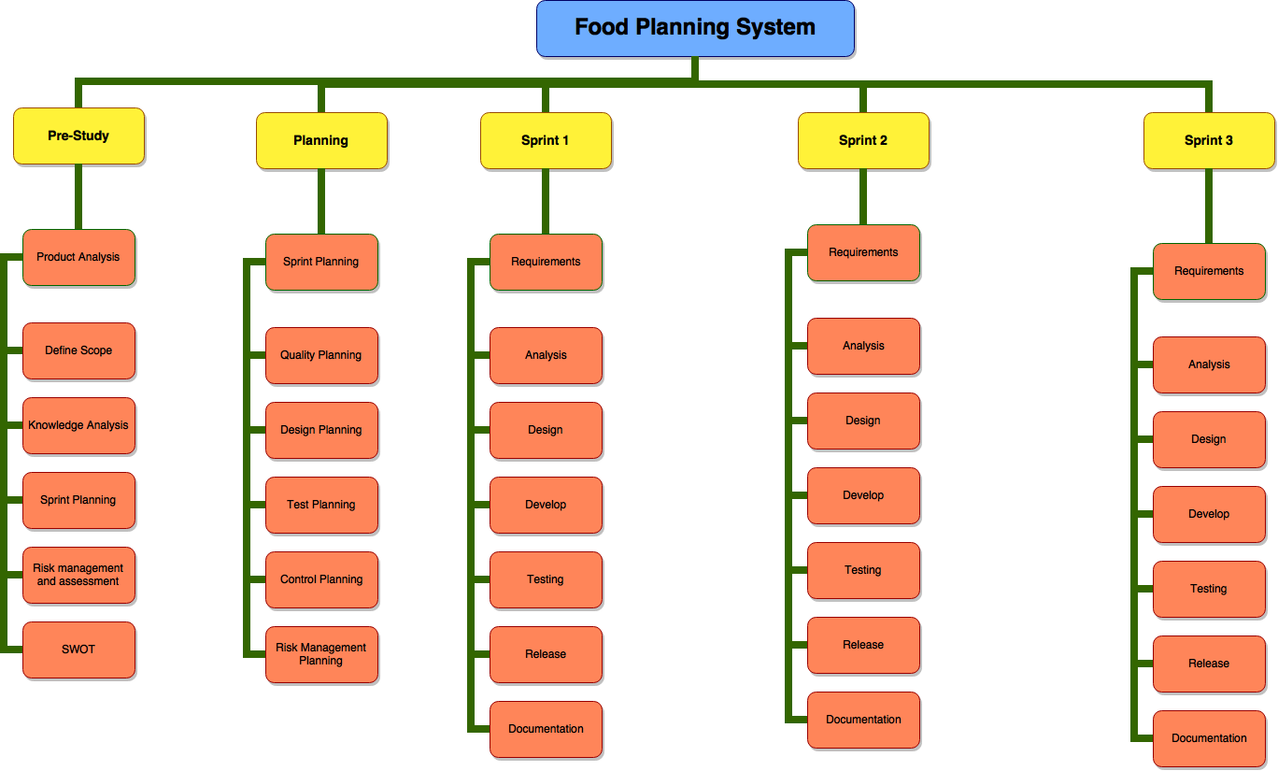

**Scope Verification**

The scope will be compared each week of the project against the original scope, and verify which deliverables are under construction or completed. There will be one opportunity of feedback on the 15th of November which hopefully provides the project team a heads up for any deliverables needed to be added.

**Scope Control**

The control will be handled by all team members. They will have to follow the WBS and generate the deliverables for each WBS element. The whole team is supposed to oversee the progression of the project to ensure that the control process is followed i.e. that its following the WBS. All requested changes to the scope must be processed so everyone’s ideas are getting accounted to. The requested change to the scope should be discussed in the group, and no documentation of the change request is needed but if accepted it has to get carried out in all affected documents.